* Task 1: Create and configure Azure AD users
* Task 2: Create Azure AD groups with assigned and dynamic membership
* Task 3: Create an Azure Active Directory (AD) tenant (Optional - lab environment issue)
* Task 4: Manage Azure AD guest users (Optional - lab environment issue)

Task 1: Create and configure Azure AD users

In the Azure portal, search for and select **Azure Active Directory**.On the Azure Active Directory blade, scroll down to the **Manage** section, click **User settings**, and review available configuration options.On the Azure Active Directory blade, in the **Manage** section, click **Users**, and then click your user account to display its **Profile** settings.Click **Edit properties**, and then in the **Settings** tab, set **Usage location** to **United States** and click **Save**

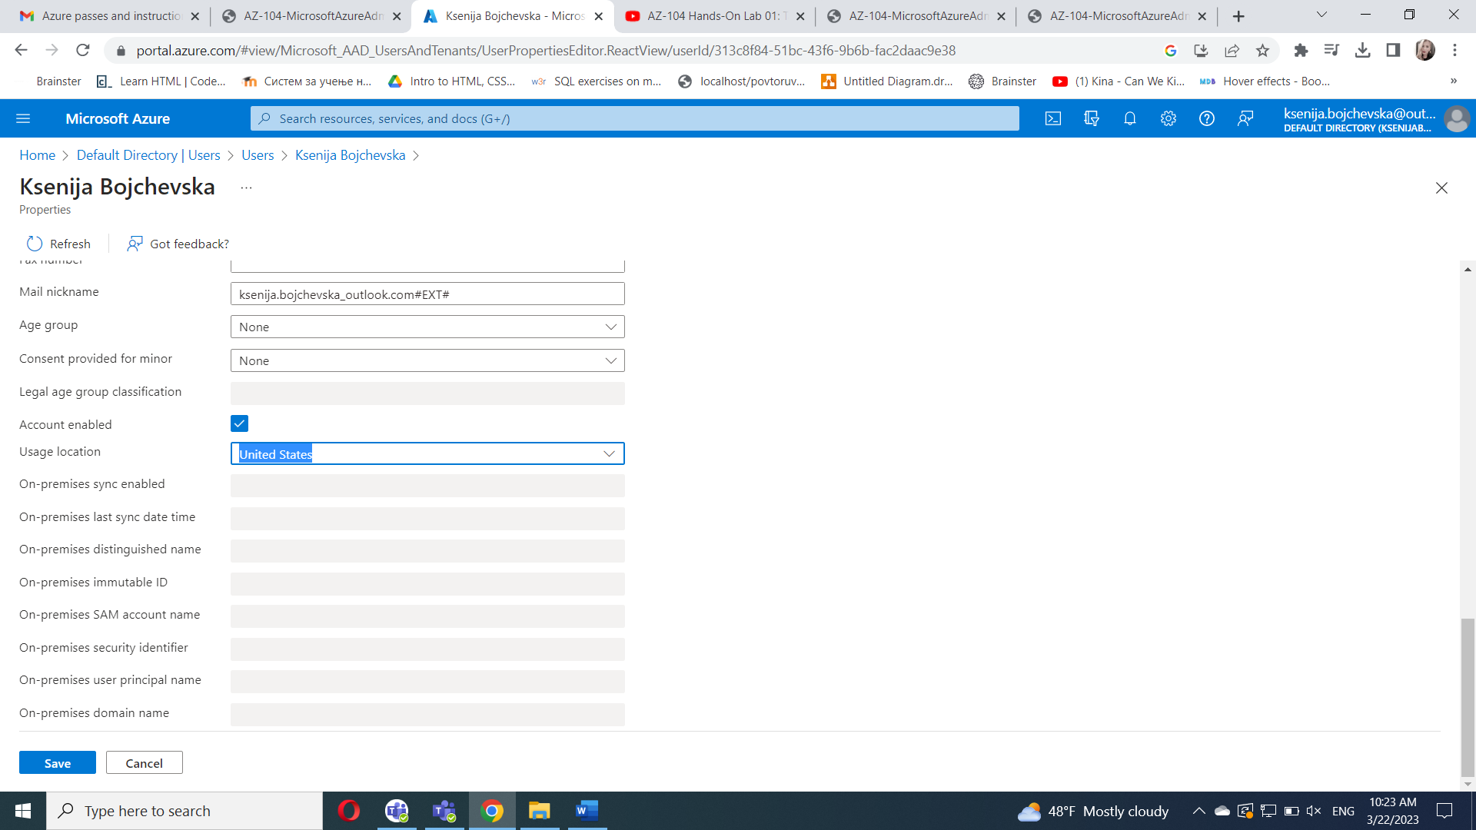

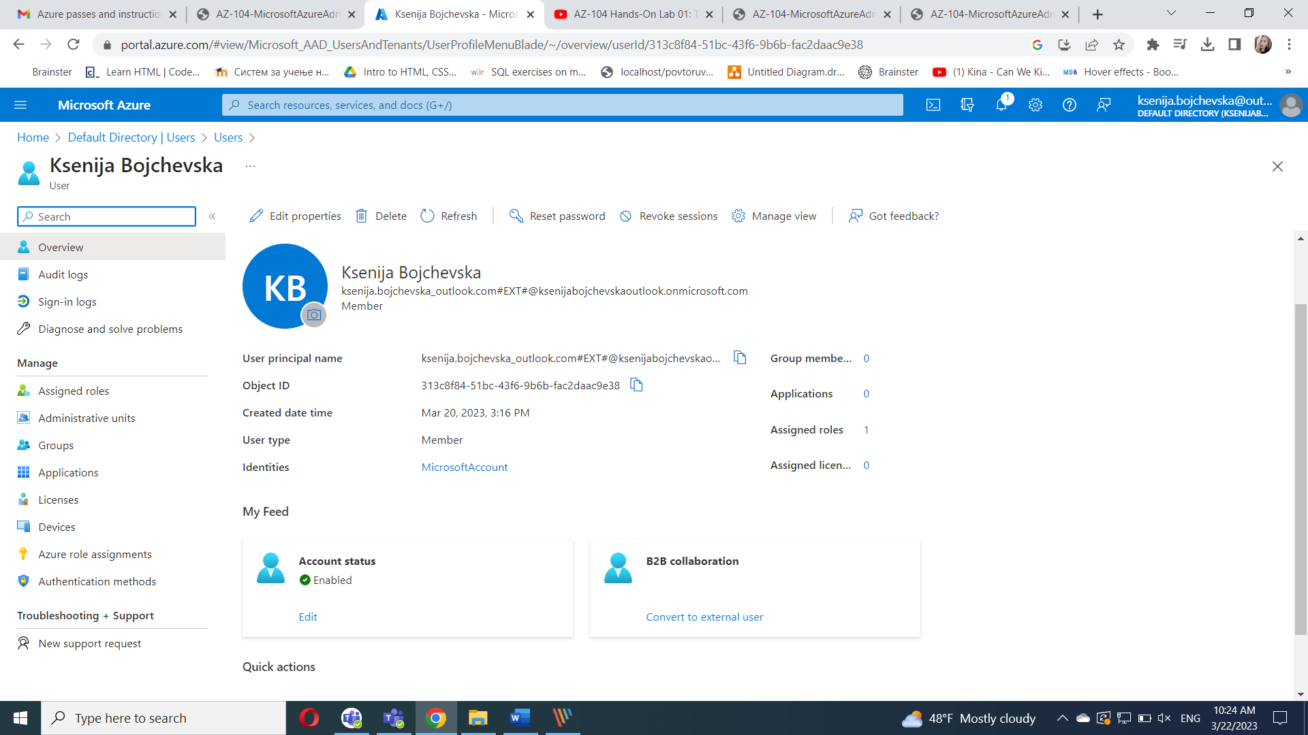

 to apply the changeNavigate back to the **Users - All users** blade, and then click **+ New user**. Create a new user with the following settings

In the list of users, click the newly created user account to display its blade.

Review the options available in the **Manage** section and note that you can identify the Azure AD roles assigned to the user account as well as the user account’s permissions to Azure resources.

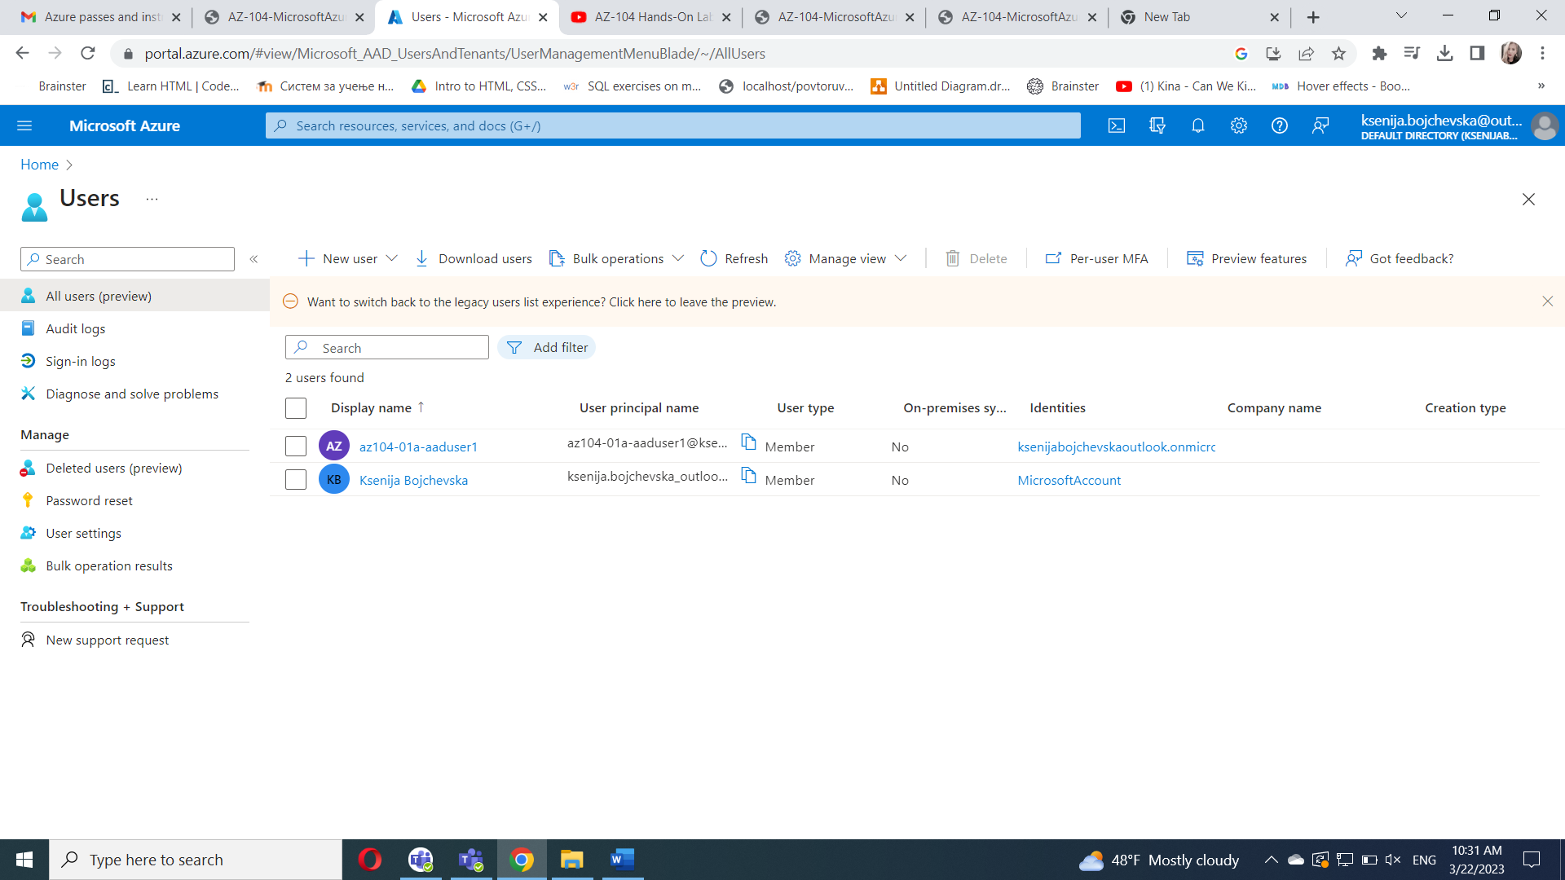

In the **Manage** section, click **Assigned roles**, then click **+ Add assignment** button and assign the **User administrator** role to **az104-01a-aaduser1**.

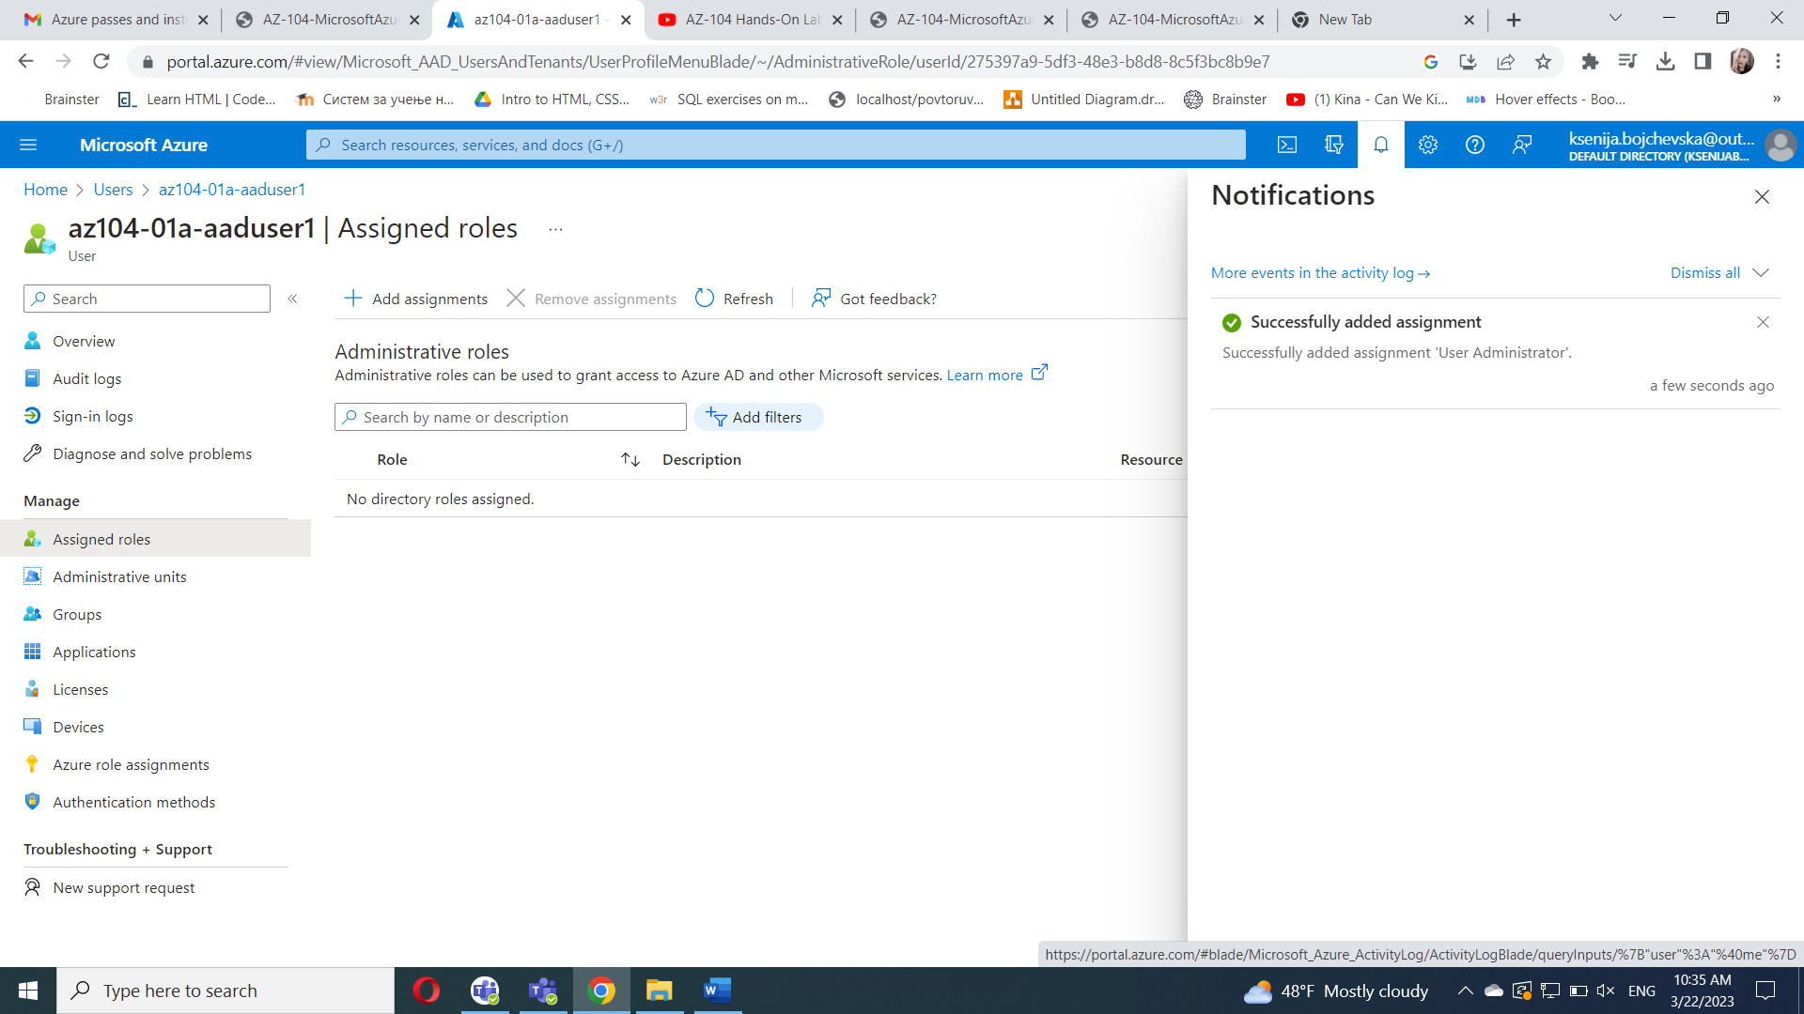

Open an **InPrivate** browser window and sign in to the [Azure portal](https://portal.azure.com/) using the newly created user account. When prompted to update the password, change the password to a secure password of your choosing.

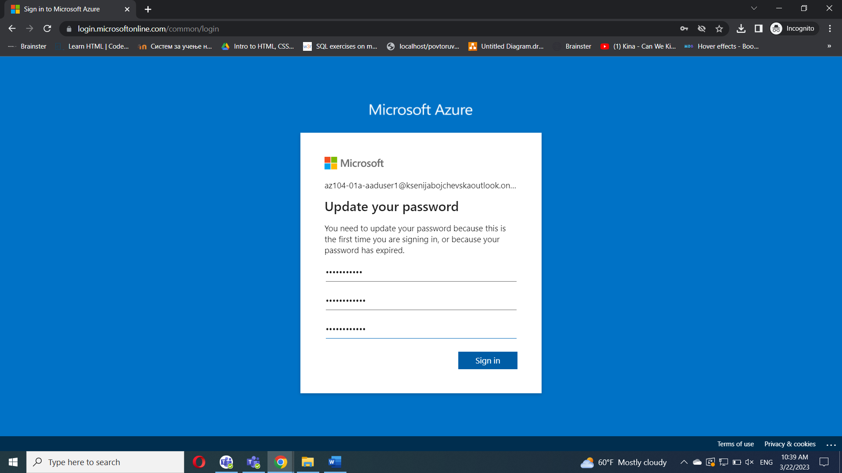

#### Task 2: Create Azure AD groups with assigned and dynamic membership

Back in the Azure portal where you are signed in with your **user account**, navigate back to the **Overview** blade of the Azure AD tenant and, in the **Manage** section, click **Licenses**.

In the **Manage** section, click **All products**.

Click **+ Try/Buy** and activate the free trial of Azure AD Premium P2.

Refresh the browser window to verify that the activation was successful.

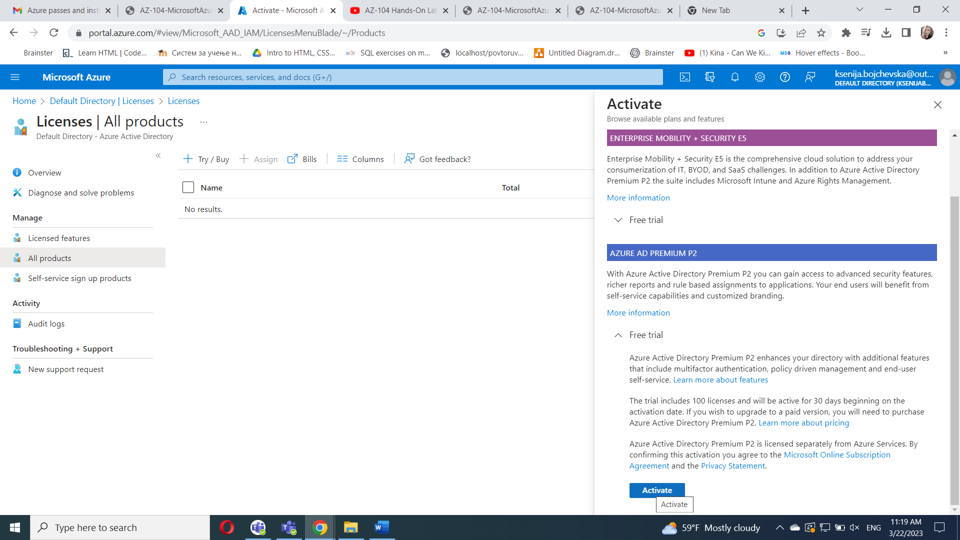

From the **Licenses - All products** blade, select the **Azure Active Directory Premium P2** entry, and assign all license options of Azure AD Premium P2 to your user account and the two newly created user accounts.

In the Azure portal, navigate back to the Azure AD tenant blade and click **Groups**.

Use the **+ New group** button to create a new group with the following settings:

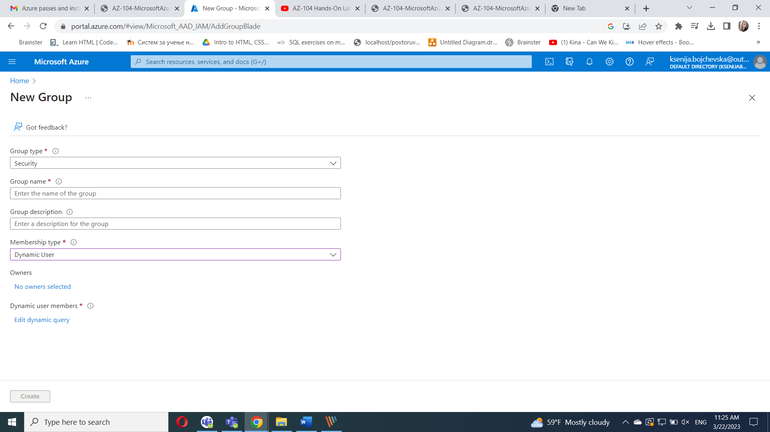

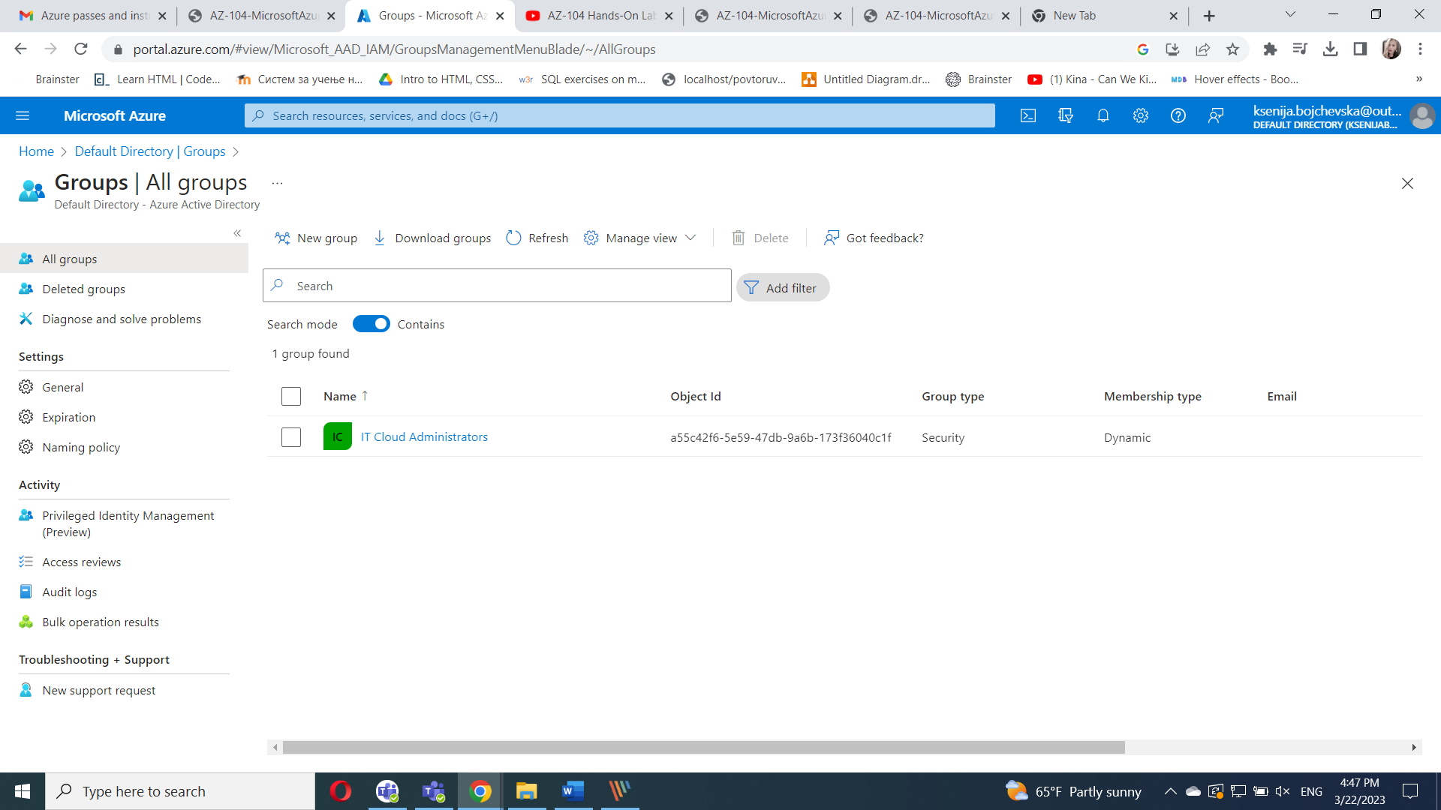

**Groups - All groups** that are created

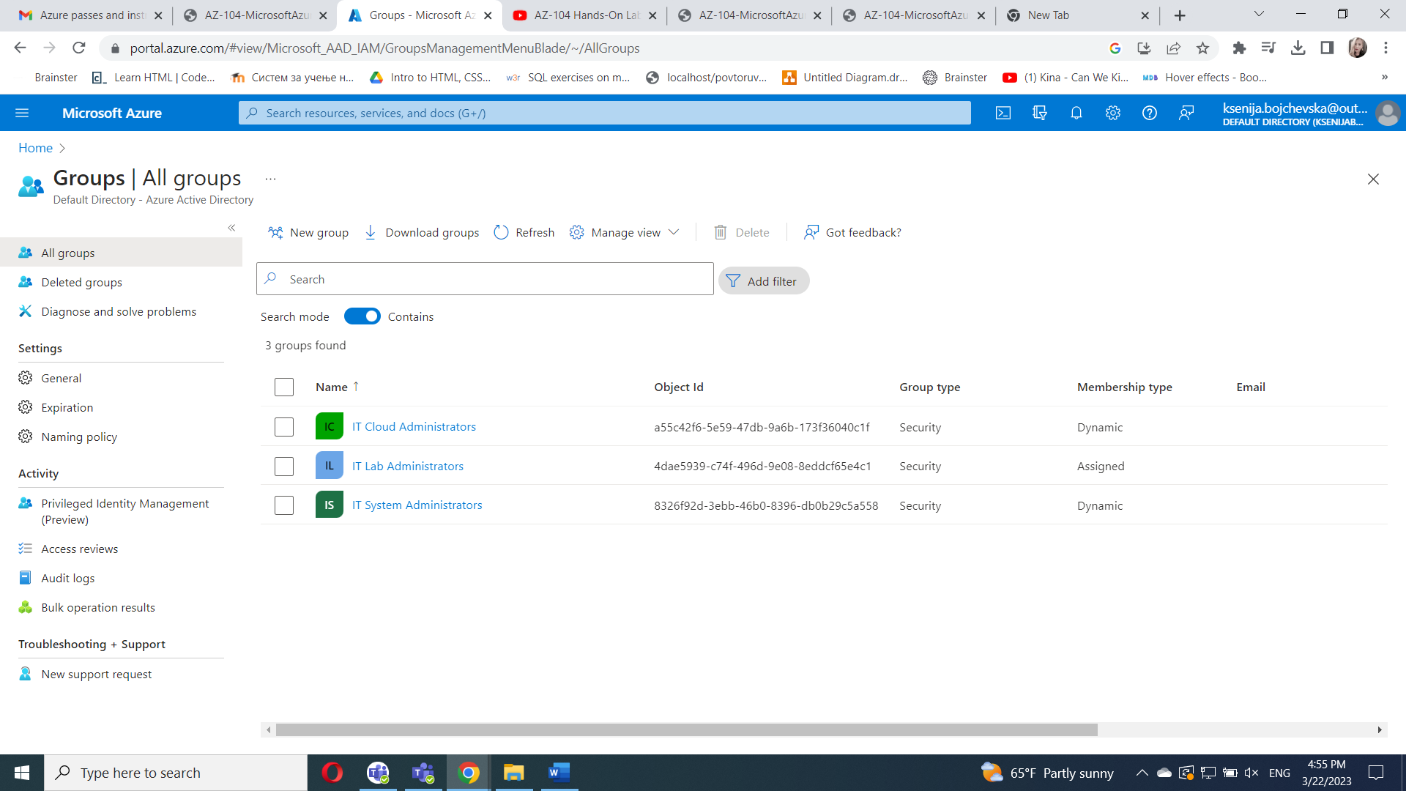

Back on the **Groups - All groups** blade, click the entry representing the **IT Cloud Administrators** group and, on then display its **Members** blade. Verify that the **az104-01a-aaduser1** appears in the list of group members.

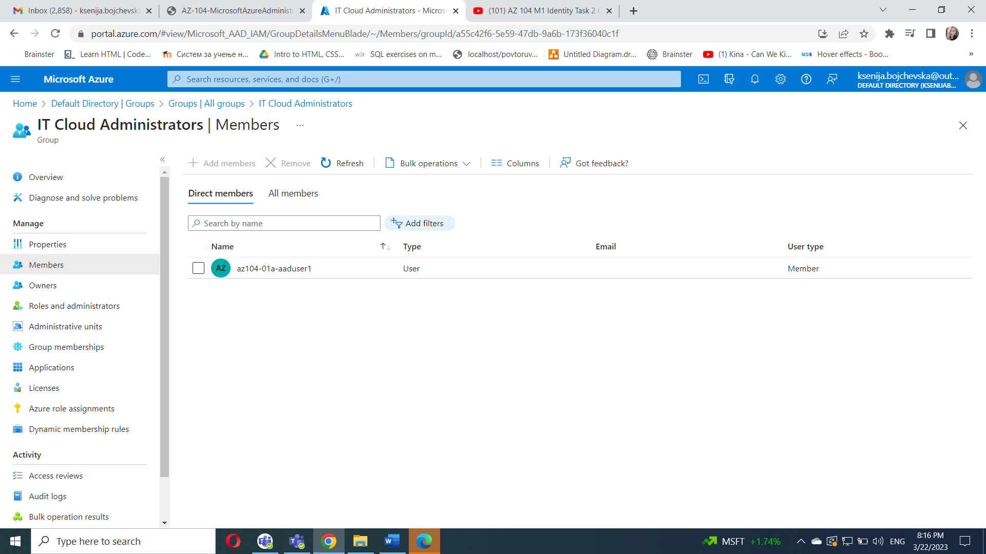

Navigate back to the **Groups - All groups** blade, click the entry representing the **IT System Administrators** group and, on then display its **Members** blade. Verify that the **az104-01a-aaduser2** appears in the list of group members.

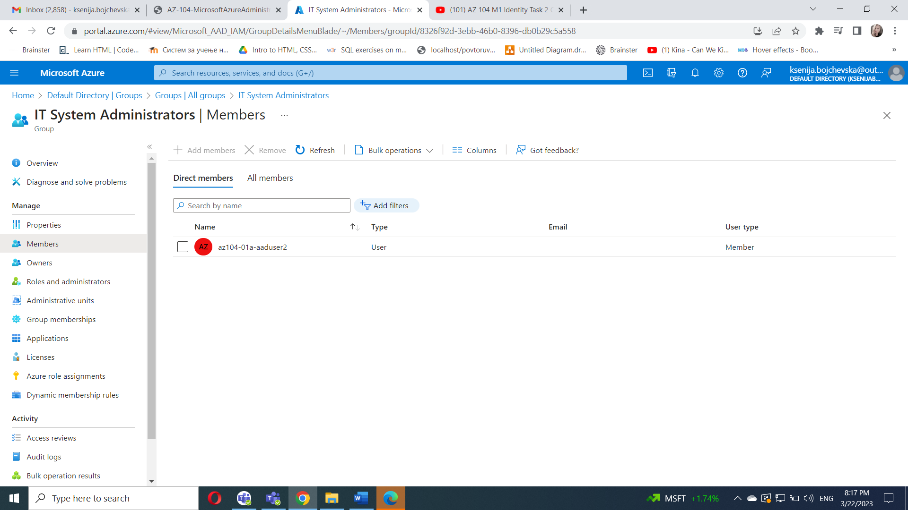

#### Task 3: Create an Azure Active Directory (AD) tenant (Optional - Lab environment issue)

1. In the Azure portal, search for and select **Azure Active Directory**.
2. Click **Manage tenants**, and then on the next screen, click **+ Create**, and specify the following setting:

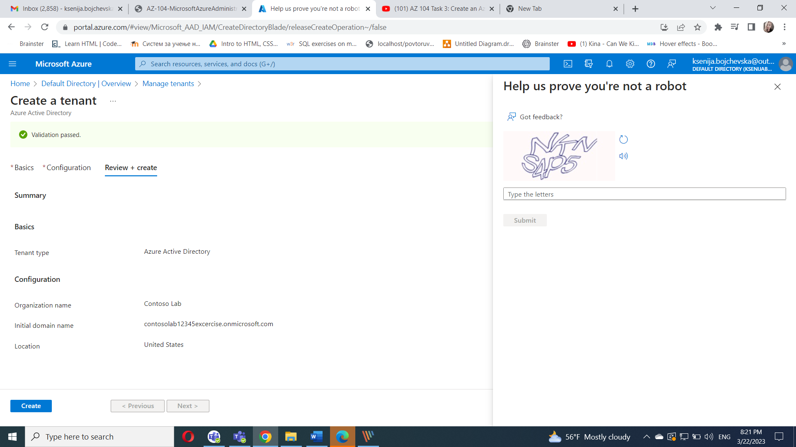

Click **Next : Configuration**

Click **Review + create** and then click **Create**.

Display the blade of the newly created Azure AD tenant by using the **Click here to navigate to your new tenant: Contoso Lab** link or the **Directory + Subscription** button (directly to the right of the Cloud Shell button) in the Azure portal toolbar.

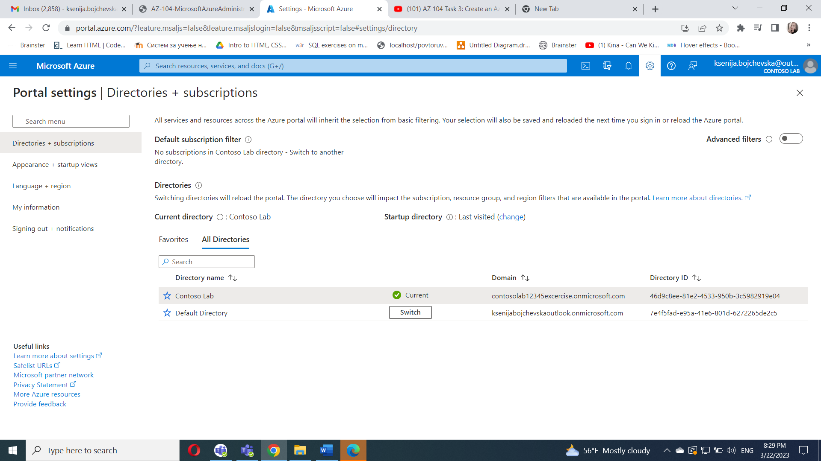

#### Task 4: Manage Azure AD guest users.

In this task, you will create Azure AD guest users and grant them access to resources in an Azure subscription.

In the Azure portal displaying the Contoso Lab Azure AD tenant, in the **Manage** section, click **Users**, and then click **+ New user**.

Create a new user with the following settings (leave others with their defaults):

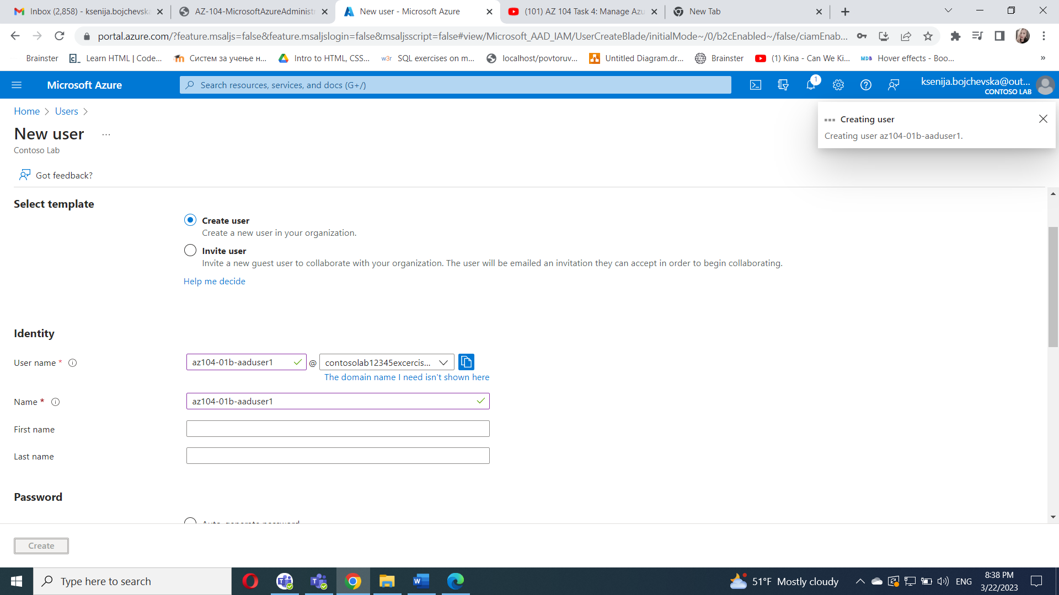

Switch back to your default Azure AD tenant by using the **Directory + Subscription** button (directly to the right of the Cloud Shell button) in the Azure portal toolbar.

Navigate back to the **Users - All users** blade, and then click **+ Invite external user**.Invite a new guest user with the following settings (leave others with their defaults):Click **Invite**.

Back on the **Users - All users** blade, click the entry representing the newly created guest user account.

On the **az104-01b-aaduser1 - Profile** blade, click **Groups**.Click **+ Add membership** and add the guest user account to the **IT Lab Administrators** group.

